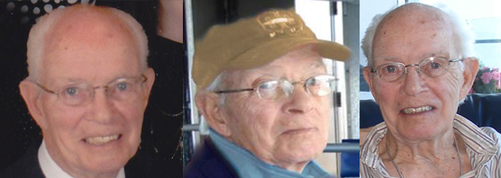

Email from the Family of Missing 85 Year Old Hugh Turner,
Who are Neighbours of Julie and Paul Wilson:

Dear Neighbours,

Thank you for all your kind words and prayers at this difficult time. I am writing to ask you to help me by forwarding this link to as many people you know and ask them to forward it as well. We all know people who live in the United States and they know people in Arizona so my hope is this will reach
a wide population.

My 85 year old father went missing on Christmas eve from his Mesa, Arizona home. He went for his daily walk at 11 am and never returned. Police, Search and Rescue K-9 units, helicopter searches, desert searches, door to door knocking with hundreds of volunteers for 3 weeks did not turned up any solid leads as to his whereabouts past December 24rth. Since then we have been using all forms of media to try to reach out to the public. We have heard stories of people helping elderly people, giving them rides, taking them in and taking them to new neighbourhoods. We don't know if my father has died somewhere obscure, had a stroke or just got terribly confused. There is no evidence of foul play but perhaps an accident happened? He isn't in any of the hospitals and the search has been thorough in and around his Mesa district and for 7 miles to the south and 4 miles to east, west and north as his neighbourhood borders the edge of town.

If you could just cut and paste this link and pass it to your friends with a brief heading to pass it on I would be very grateful. It includes a 1 minute video suggesting how others can help. We pray that somewhere, someone has seen him and will become aware that we need them to help us further.

http://helpfindhughturner.com

Thank you
Janice & Bill and the Turner Family

